I
nstalling templates
in
B
est Practice

Q
uick reference sheet

WARNING
Do not open / modify / edit templates in Microsoft Word,
as it will corrupt the template tags.
Best Practice templates can only be modified in Best Practice

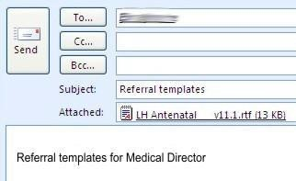
Saving templates
For templates received as an email attachment
Open email -- Right click on
Attached file and select Save as.

Navigate to your computer desktop.
Then click Save.

OR
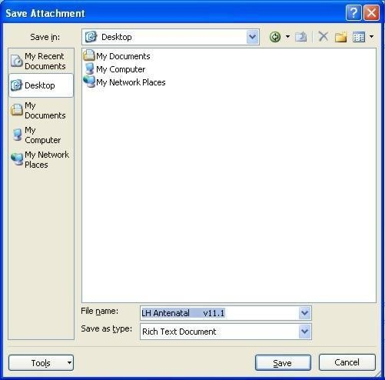

For templates downloaded from the Internet
Click on Download on the website you are on and save on your computer desktop as above.

Installing templates
In Best Practice main screen, open Word Processor by clicking on this icon. In the Word Processor, go to Templates - Import Template
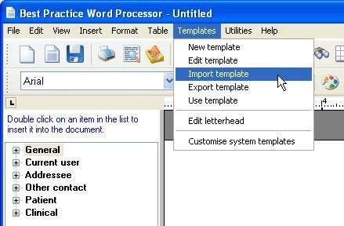
Navigate to template’s location (desktop) in the same manner as for Saving on previous page. Select the template you wish to import and then click Open. The template will appear in the word processor.

Saving the template: Go to File --- Save As Name the file following your practice naming protocol. Check available to all users.

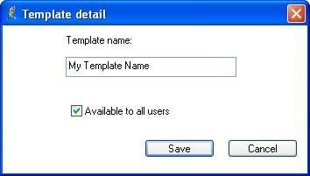
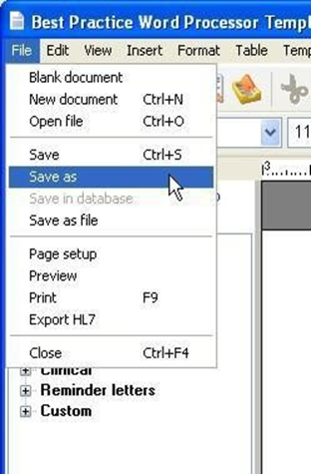

Click on Save.

Test the template to make sure it is working as expected.

Congratulations! You have successfully installed a template in Best Practice.

