I
nstalling templates
in Medical Directo
r

Q
uick reference sheet

WARNING
Do not open / modify / edit templates in Microsoft Word,
as it will corrupt the template tags.
Medical Director templates can only be modified in Medical Director

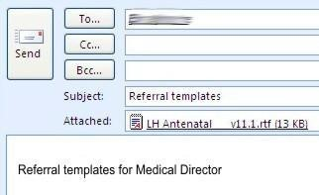
Saving templates

For templates received as an email attachment
Open email -- Right click on
Attached file and select Save as.

Navigate to your computer desktop. Then click Save.

OR
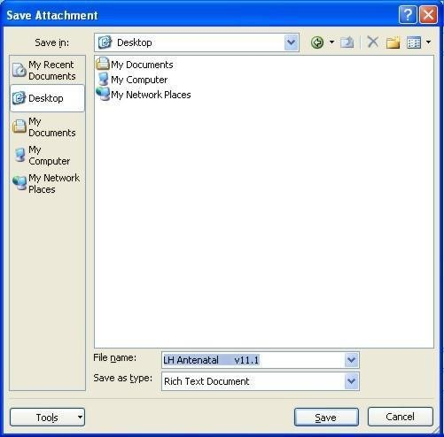

For templates downloaded from
the Internet
Click on Download on the website you are on and save on your computer desktop as above.

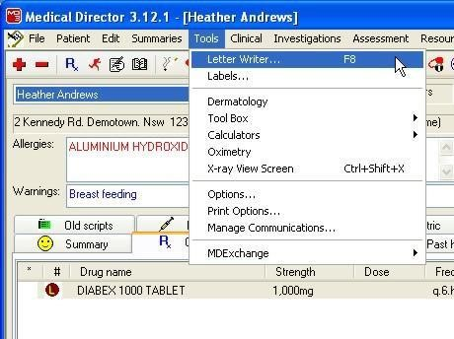
Installing templates

In Medical Director main screen or patient record, go to Tools – Letter Writer

The program may be set to immediately ask which template you wish to use. Cancel this action

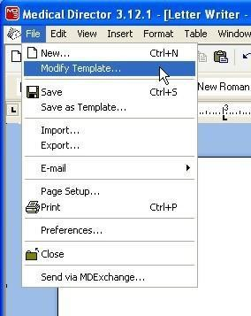
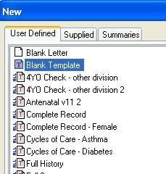
Go to File
– Modify Template

Then select Blank
Template and click
OK

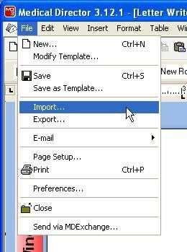
Go to File - Import

Navigate to templates location (desktop) in the same manner as for Saving on previous page. Select the template you wish to import and then click Open. The template will appear in the word processor.

Save the template
Go to File - Save as Template.
Name the template, following your practice naming protocol. Select ALL USERS. Click Save
Test the template to make sure it is working as expected.

Congratulations! You have successfully installed a template in Medical Director.

